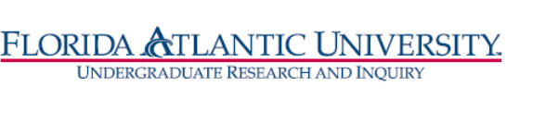
Florida Atlantic University
Undergraduate Research Curriculum Committee
Thursday, November 18, 2021
WebEx meeting from 12:30 to 1:30 pm

- Approve October 28, meeting minutes
- RI Certificate updates
- Substitution and Waivers form updated on CANVAS
- Website updated
- Existing waivers and substitution requests process
  - Fall students – Lopez, Kevin, Jarron, Michelle and Sara Hollenback
  - Spring eligibility student list
- Next steps after URCC approval
  - Letter from OURI to advisor/registrars notifying of URCC approval for waiver/substitution.
- Discussion of advertising the certificate for Spring.

