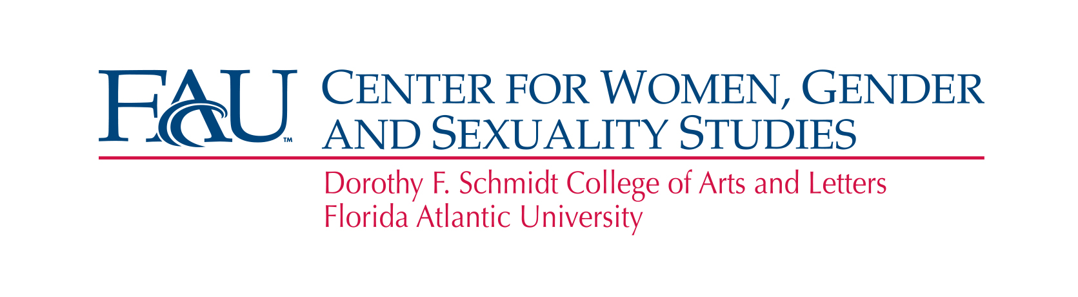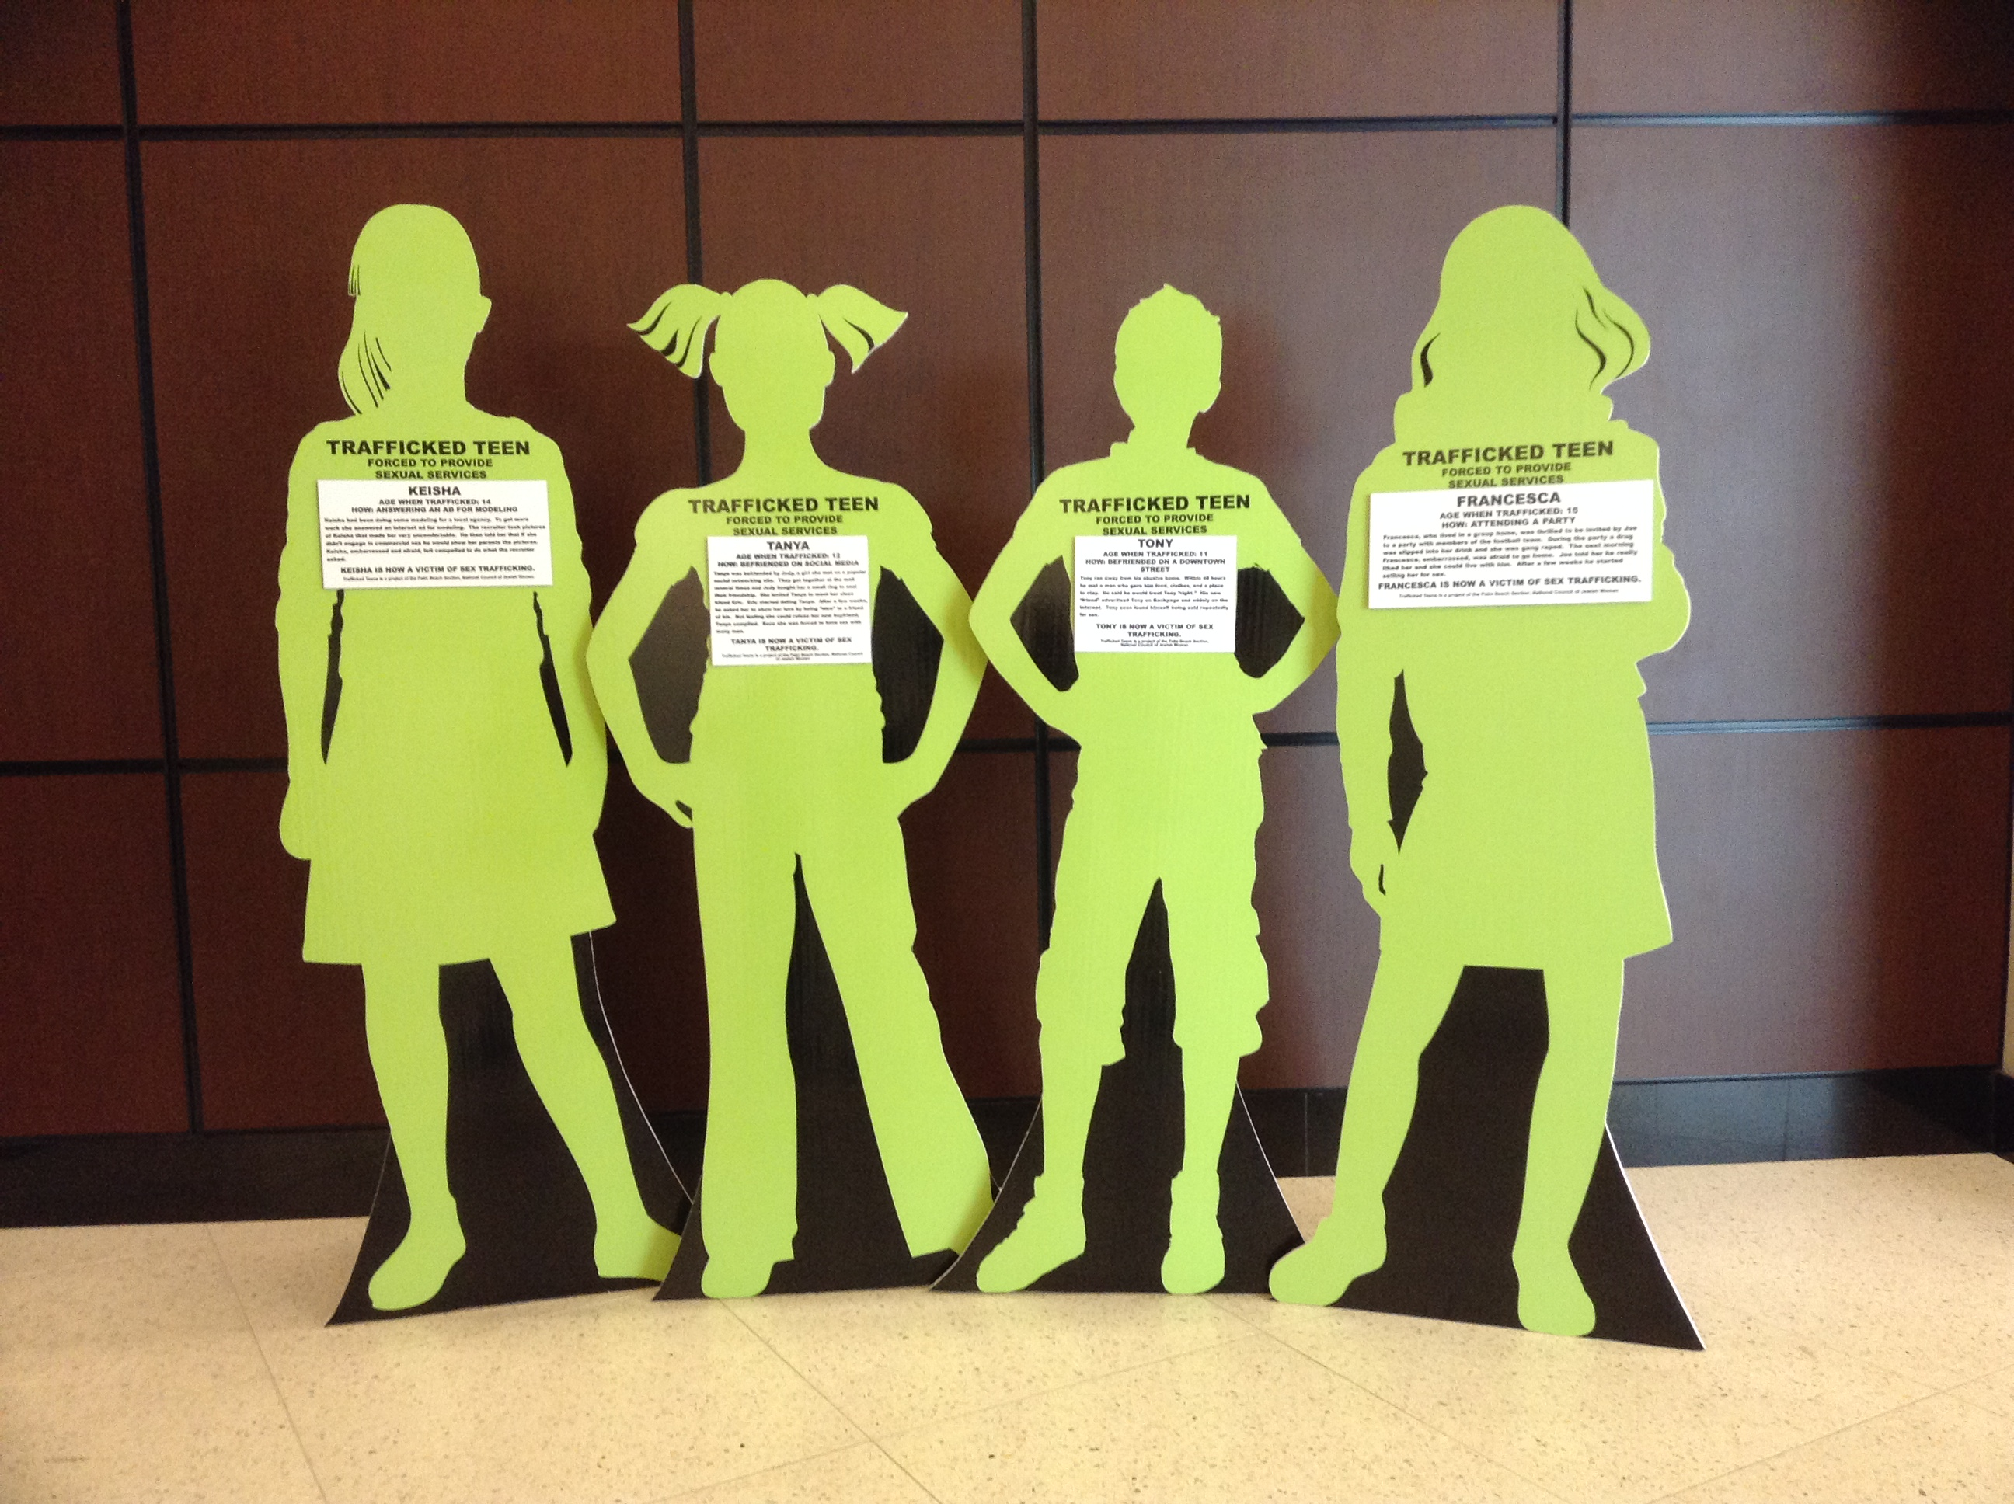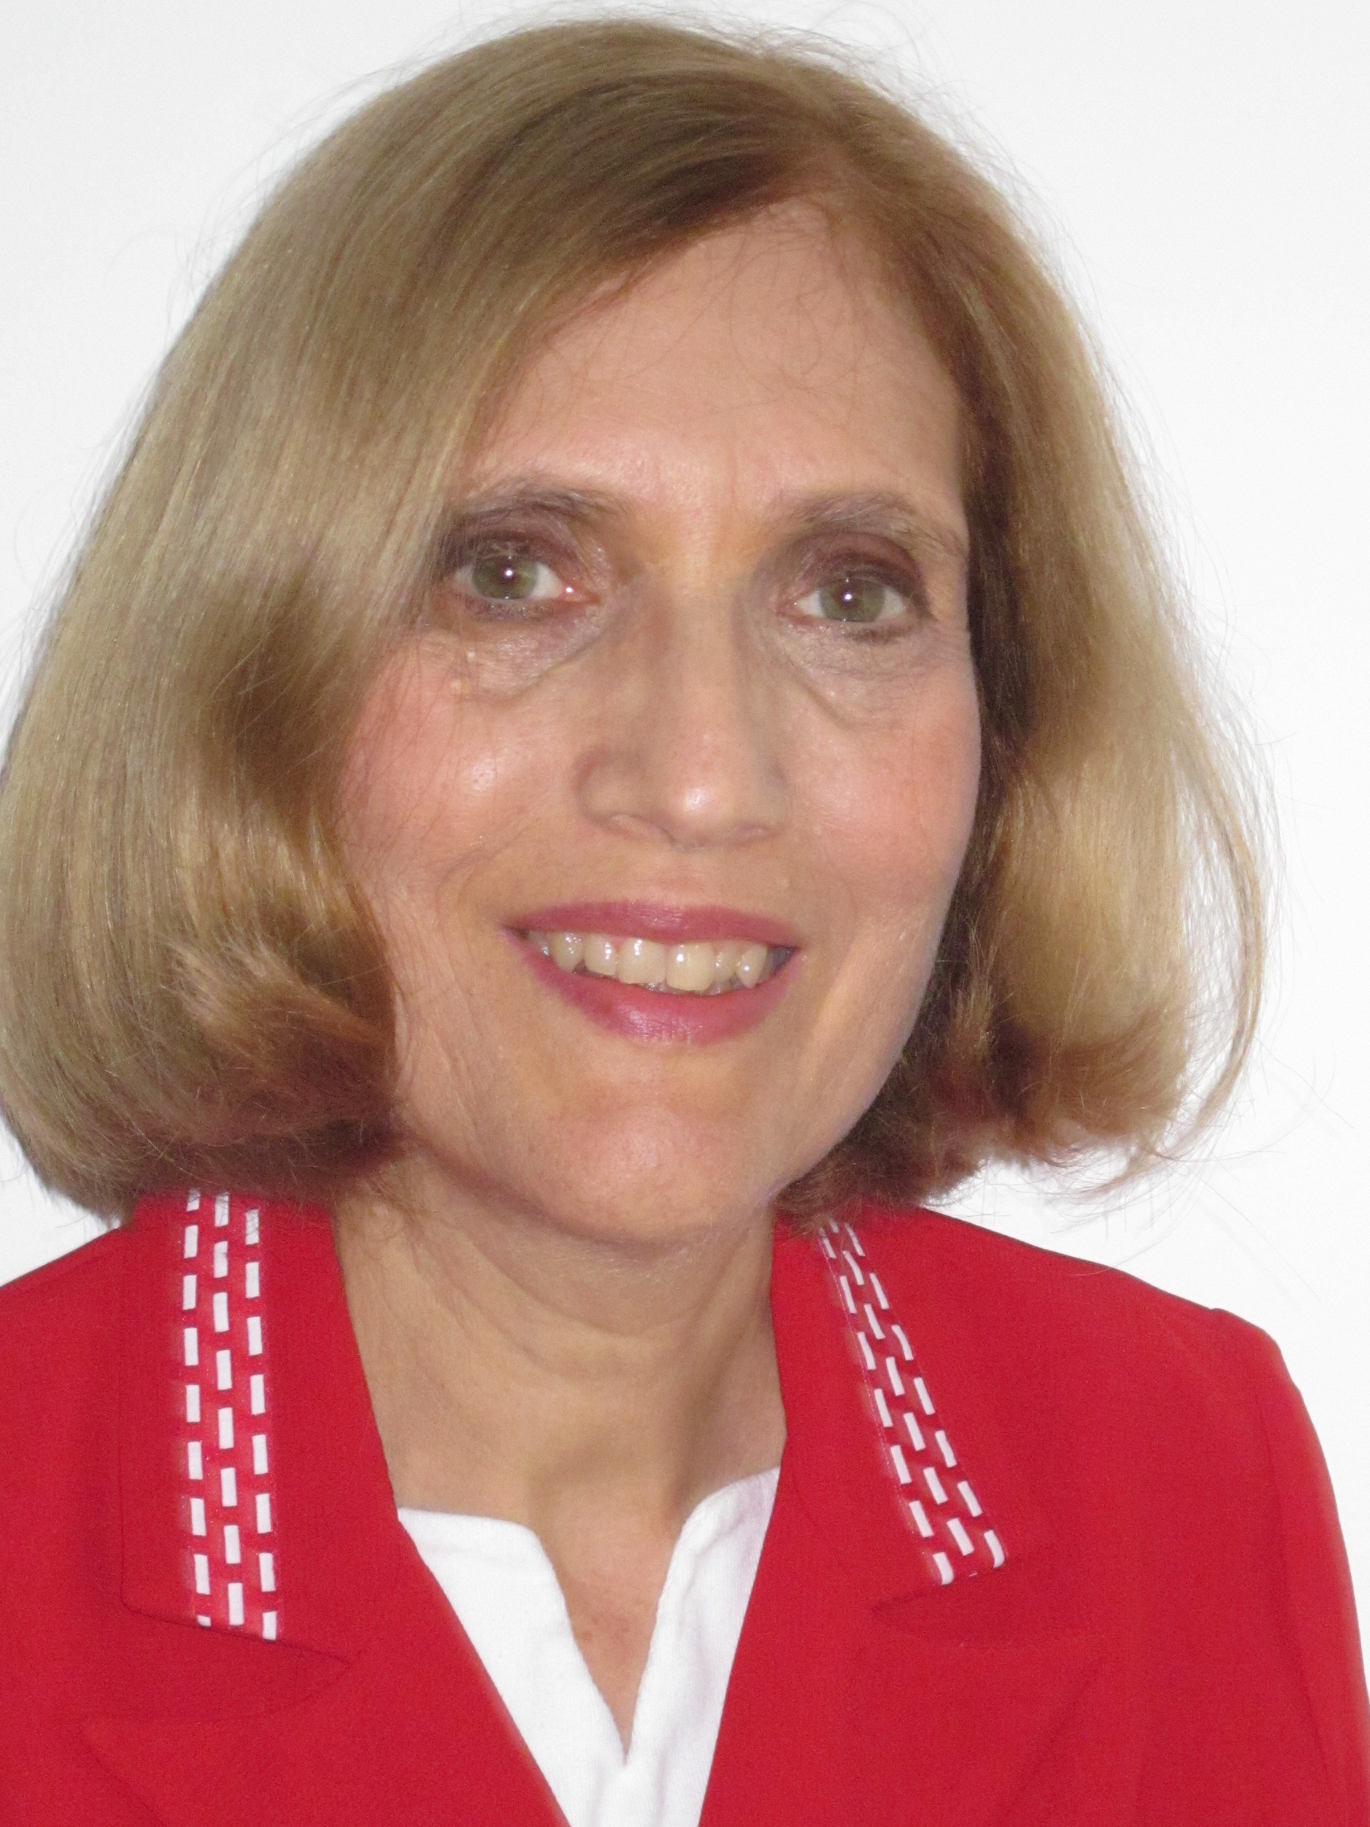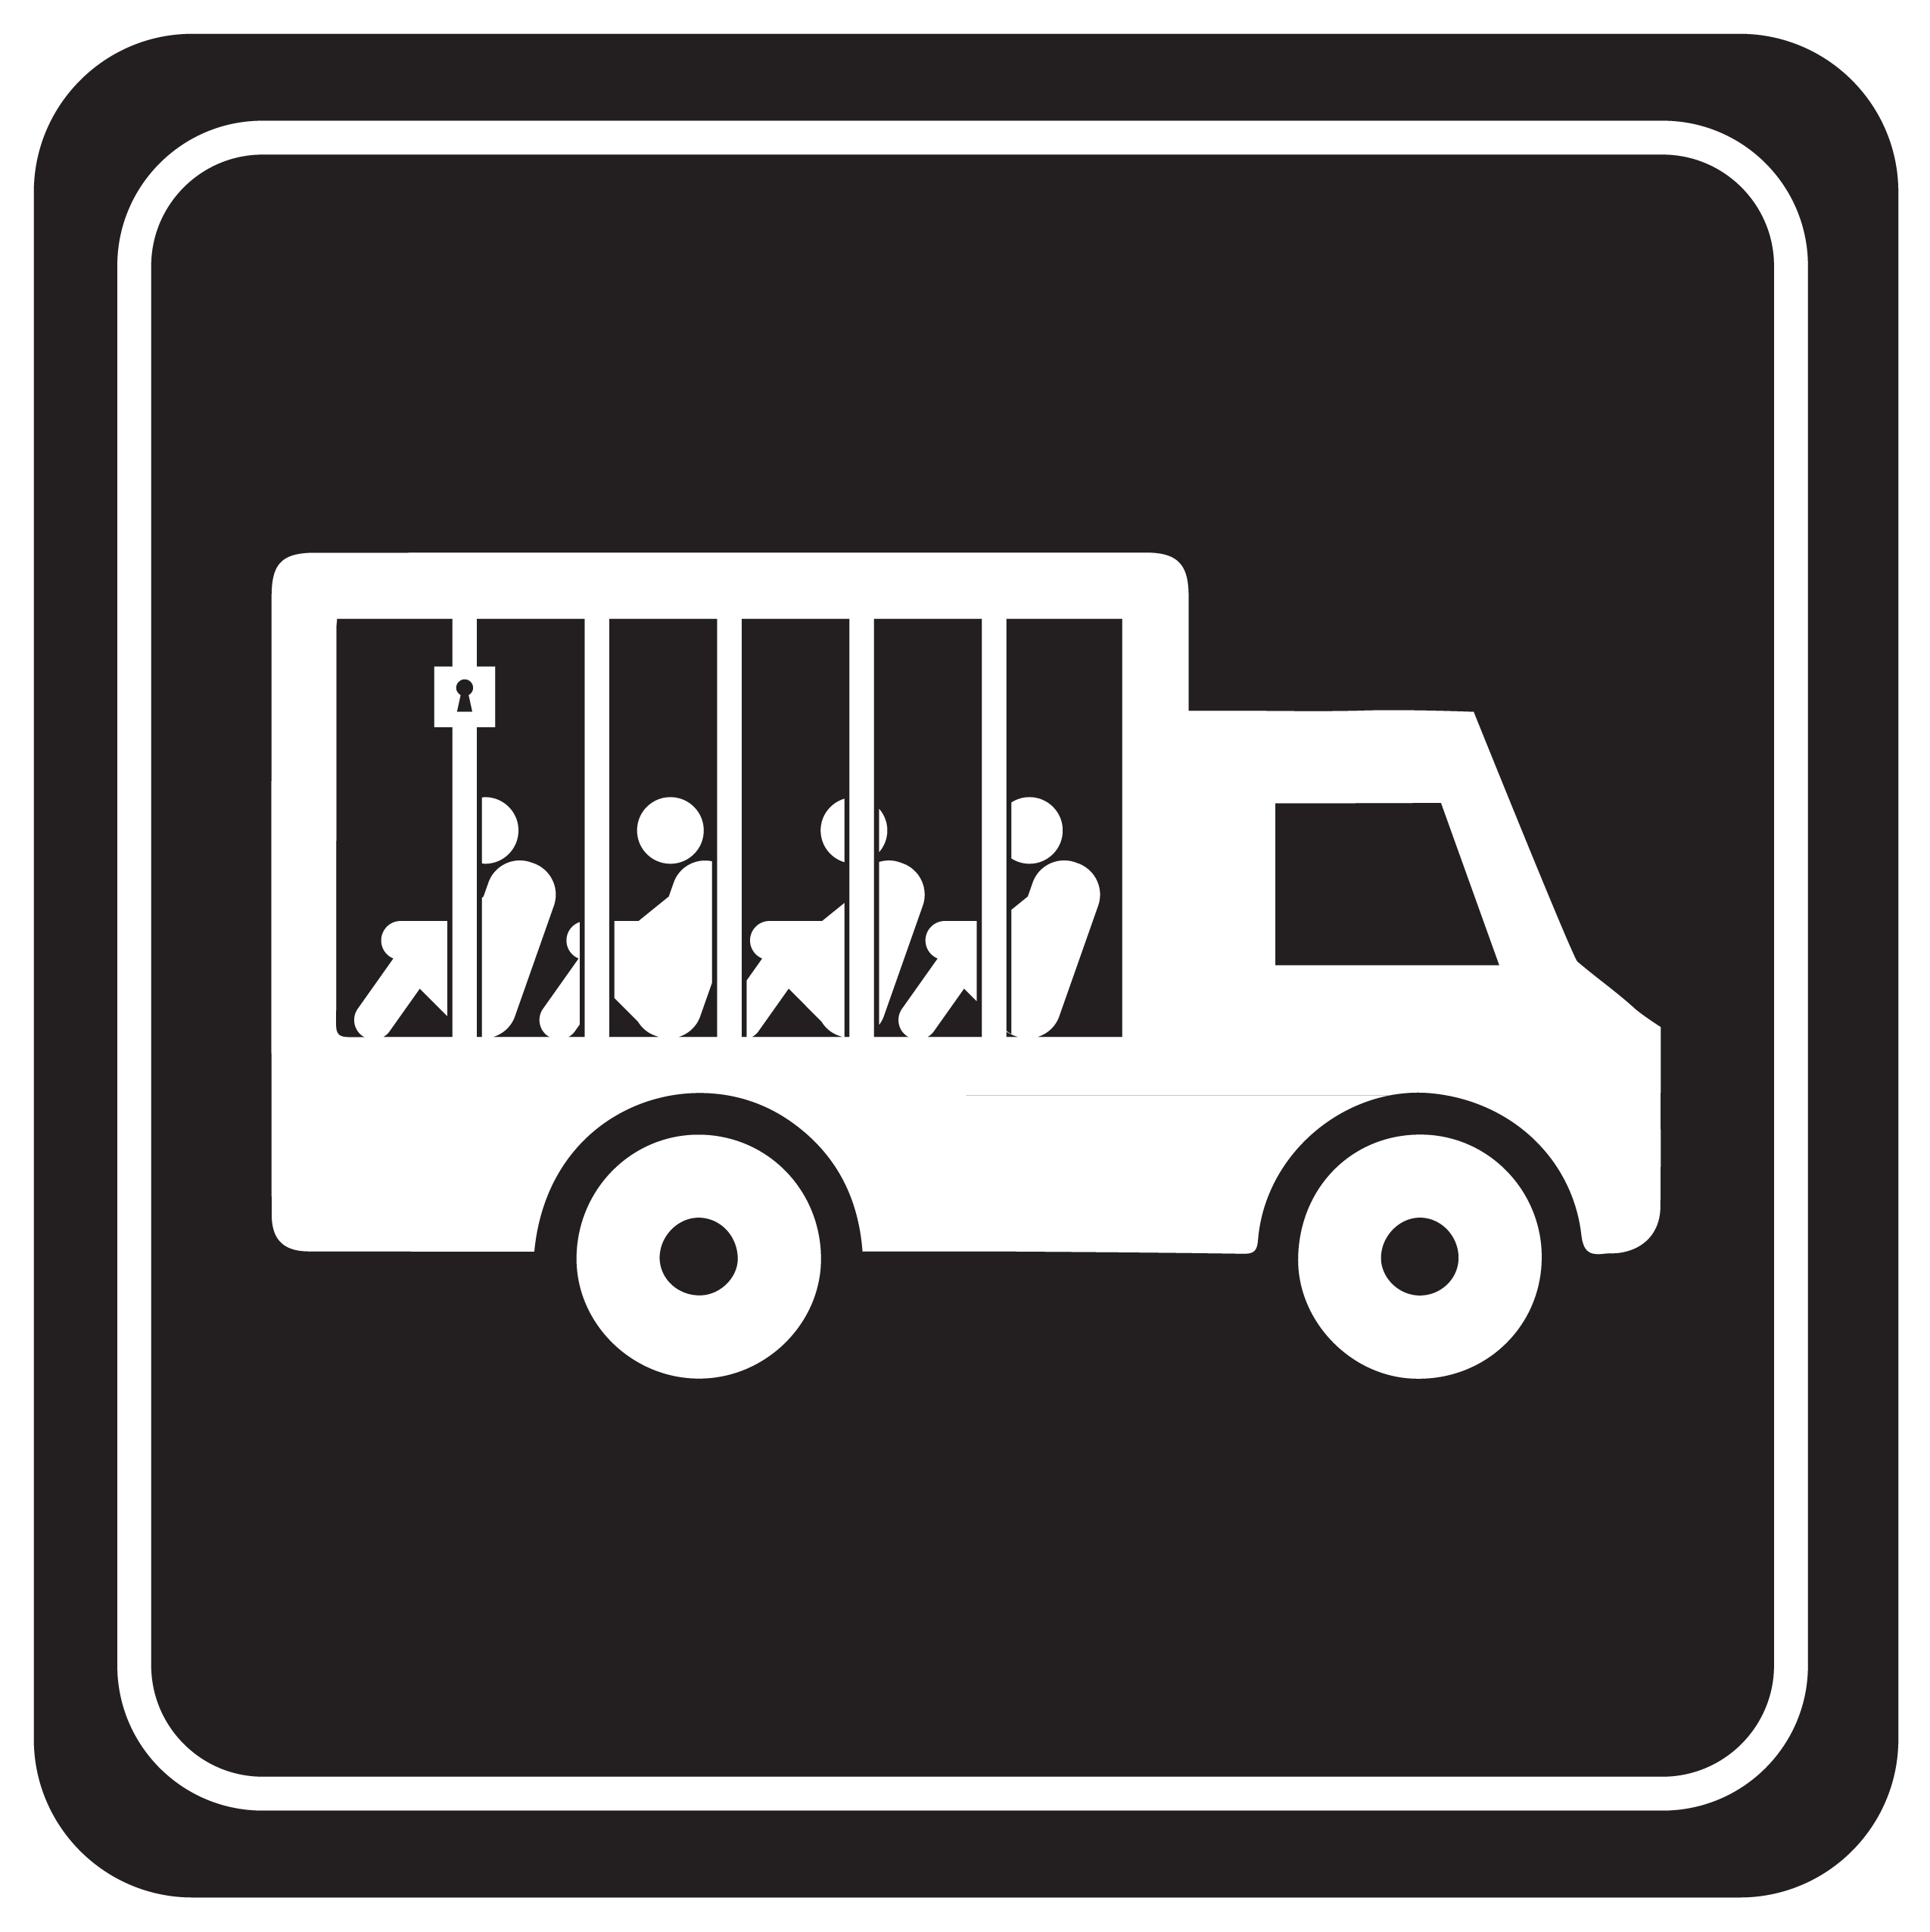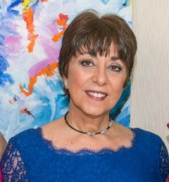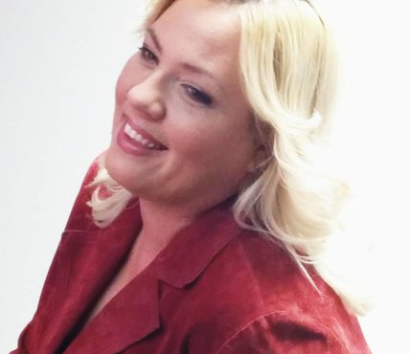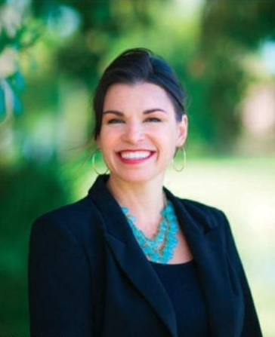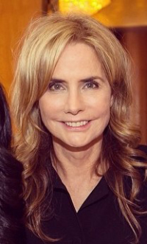

# Many thanks…

Let us know what support you need to make

your awareness campaigns on FAU’s campus a success!

Contact the WGSS Center at [wsc@fau.edu](mailto:wsc@fau.edu) or (561) 297-3865.

Raising awareness campaigns that are successfully coordinated by FAU students will be recognized and honored at the

*Southeastern Women’s Studies Association* Conference held

at the Wyndham Hotel in Boca Raton from **March 26-29, 2015**.

The conference will be attended by scholars from Alabama, Florida, Georgia, Kentucky, Mississippi, North Carolina, South Carolina, Tennessee, and Virginia.

Our gratitude goes to the WGSS Center’s Advisory Council for their leadership and fundraising support. Thanks to the Dorothy F. Schmidt College of Arts and Letters for its collaborative research grant. The Building Bridges luncheon is part of “Surviving Slavery: ‘Sex Trafficking in South Florida,” a research initiative of FAU’s

Center for Women, Gender and Sexuality Studies.

# Get Support! Get Recognition!

End Sex Trafficking Now!

**Keynote Speech** by Katie Ford

**Break-out Sessions** moderated by WGSS Faculty

Associates and FGSA mentors

* Mark Harvey, Department of Sociology
* Talitha Leflouria, Department of History
* Bernadette Lange, College of Nursing

Luncheon Agenda

# Introduction by Elena Machado, WGSS Director and

# Associate Professor of English

Be the solution!

2014 Building Bridges Leadership Luncheon

#### Florida Atantic University’s Center for Women, Gender and Sexuality Studies (WGSS) welcomes you to the

Friday, September 12, 2014 from 1:00-3:00pm

Majestic Palm Room, Boca Raton Campus

# Feminist Graduate Student Association Mentors

Arely Lozano-Baugh, Britni Hiatt, Mary Reid Bogue, Rene Perez, Christele Gassant, Atticus Ranck, and Jessica Osman.

### Elizabeth Fisher,President of *Selah Freedom*

### Connie Rose, Director of Survivor Leadership

The “Re-directing Traffic” project by Audrey Aurigemma, Adrian Beuses, and Veronica Metzler focused on creating a successful advertising campaign that redesigned a common traffic sign to raise awareness, with the goal of placing it in unorthodox locations in which high levels of trafficking occur: airports, bus stops, brothels, manicure salons, and factories. We are hoping that it will spark communication on the severity of the situation to those uninformed of this global crisis.

**Student Leadership Showcase: Visual Arts**

Arely and Britni are M.A. students in the WGSS program and dedicated community activists. As research assistants for the “Surviving Slavery” research initiative, our goal is to help raise awareness about sex-trafficking locally and about the global connections this industry depends on.

# Arely Lozano-Baugh and Britni Hiatt,

# Research Assistants for the WGSS *Surviving Slavery* initiative

Linda Geller-Schwartz earned her PhD at the University of Toronto and has taught Women's Studies and Sociology courses at FAU. She is the Florida State Policy Advocate Co-chair for the National Council of Jewish Women and one of the creators of new Trafficked Teens project, specifically designed to highlight child sex trafficking.

**Linda Geller-Schwartz**, Co-chair of *Partner Organization Against Sex Trafficking* (POAST)

Katariina Rosenblatt, has a PhD in conflict analysis and resolution and works closely with law enforcement agencies, such as the FBI and Homeland Security, to eliminate human slavery. She founded *There Is Hope for Me*, a nonprofit organization dedicated to freeing other victims of human trafficking.

*Selah Freedom* exists to confront the issue of sex trafficking and exploitation through advocacy, training and restorative services. *Selah Freedom* brings awareness to the issue of sex trafficking and provides a safe place for survivors to heal. We help sexually exploited individuals find their voice and purpose and to reclaim all that was stolen from them through their victimization.

Community Partners and Student Leadership

### Katariina Rosenblatt, Survivor and Founder of *There is H.O.P.E. for Me*

Freedom for All is a not-for-profit organization that partners with on-the-ground organizations to create long-term, systemic changes to end slavery in the countries where they work and to save lives by freeing people who are held in slavery.

Our Keynote Speaker and Community Partners

**Katie Ford**, Founder of *Freedom for All* and

### Former CEO of the *Ford Modeling Agency*