Department of Exceptional Student Education
College of Education
Florida Atlantic University

Instructor: Office:
Phone: E-mail:
Office Hours: Class Day/Time: Varies

Course Number: Sls2943

Course Title: Career Internship

2 Credits

Catalog Description: An in-depth supervised field experience. The student will spend an average of 10 hours per week over a 15 week semester in a job of their interest. Grading: S/U

INSTRUCTOR INTRODUCTION TO THE COURSE: This course is designed for the Florida Atlantic University Academy for Community Inclusion. In this course, students will participate in a career internship while working towards the ultimate goal of competitive paid employment. In this internship students will work with a job coach to develop specific skills for their intended career goals.

PREREQUISITE or COREQUISITE:
SLS2920 or permission of instructor

REQUIRED TEXTS or MATERIALS:

All materials will be provided by instructor in class or on Blackboard. Materials will be provided in multiple formats as appropriate.
Owl Card to access the library (Student Services)
Updated Work Portfolio including Resume
Tablet

TECHNOLOGY:

E-mail: Your FAU email will be used for this class.

Computer: This course will be web assisted through FAU Blackboard site. Some handouts, forms, handbook and resources may be available on the website. Go to the website: http://blackboard.fau.edu (Do not type www).

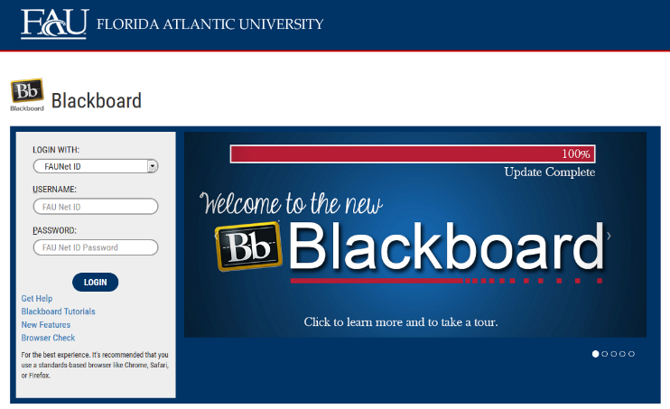

Tablet: Tablets will be used for the student to video record them self while on the job. At the end of the internship, the student and their job coach will decide on two of their videos that display their best work for submission to Angelica Downey, for feedback.

COURSE OBJECTIVES:
Upon completion of this course, the successful student will be able to demonstrate the following:

- Students will show punctuality, attendance, and proper attire in that is suitable in the work place.
- Students will utilize public transportation or coordinate travel plans for arriving to their internship.
- Students will demonstrate appropriate social interactions with co-workers.
- Students will demonstrate proficiency in money skills, reading, and other academic skills required during their internship.
- Students will establish and utilize a work schedule.
- Students will deal effectively with work related stress and changes to their routine.
- Students will display honesty towards others in the work place, work initiative, and motivation.

Content Outline:

- Focusing on specific job skills and qualifications for desired career path
- Building knowledge of desired career path
- Maintaining professional relationships
- Utilizing strategies on the job to create success
- Gaining responsibility, motivation, and professionalism through the internship experience

COURSE REQUIREMENTS: (See Appendix for more details on assignments)

- Job Observation and Behavior Scale: Opportunity for Self-Determination Pre and Post Assessment- Student internships will be required to complete the JOBS (OSD) assessment prior to the start of the internship AND after the end of the internship. This is to assess the student’s growth of performance during your internship. The due date for the Pre- Assessment is: The due date for the Post-Assessment is: The student’s job coach will supply the materials and the student will complete it with them. It is the student’s responsibility to set up a time to complete the assignment with their job coach at the beginning of the semester and at the end of the semester.
- Timesheet Log- Interns will keep a time log for each day they go to work. The time log will include the date, the time began work, the time ended work, and the amount of hours spent at work that day. Students may find the timesheet in Appendix. *Students will print it out and take it with them to their job site. Students will submit their timesheet to Mrs. Downey at the end of the semester. Due Date:
- Observations and Recordings: Students will be observed and recorded by their job coach for a total of 5 times for 10 minutes. During these observations, the intern will be recorded doing their daily work tasks. After 5 recording sessions, interns and job coaches will pick two recordings that demonstrate the intern’s best work to be able to present it to Mrs. Downey for feedback. The feedback and the recordings will then be presented during the yearly student planning meeting. Note: Student observations will be recorded on their own tablet. The student’s job coach will not be able to assist them during their observations. Afterwards, students will watch the observation together (with their job coach) and complete a chart for 1- What you did well, 2- What you could work on, 3- What you need support with.

ASSESSMENT PROCEDURES:

Assignment | Points Earned | Possible
1: JOBS (OSD) Pre and Post Assessment |  | S/U
2: Timesheet Log |  | S/U
3: Observations and Recordings |  | S/U
TOTAL

GRADING (FAU GRADING SCALE):
Activity scores are cumulative and the grade scale represents percentage of total points earned.
S= 73% and higher U = 72% and lower

POLICIES AND PROCEDURES:

ATTENDANCE:
According to University policy, “Students are expected to attend all of their scheduled University Classes and to satisfy all academic objectives as outlined by the instructor.” Attendance includes meaningful, active involvement in all class sessions, class discussions, and class activities as well as professional, ethical, conduct in class. Reasonable accommodations are made for religious observances.

INTERNSHIP ATTENDANCE POLICY: If an internship student must be absent, s/he must follow the procedures described below:
- The student will inform the employer/supervisor as far ahead of time as possible that they will be absent.
- The student will make sure that the employer/supervisor has enough staff to fill the shift or be able to find someone to cover for them.
- The student must make up any time missed each week either the week before the absence or the following week.
- An absence from the internship does not absolve the student from fulfilling all responsibilities.

STUDENTS WITH DISABILITIES:
In compliance with the Americans with Disabilities Act (ADA) and FAU policy, students with disabilities who require special accommodations to properly execute course work must register with FAU Student Accessibility Services (SAS) and provide the instructor of this course with a letter from SAS indicates the reasonable accommodations that would be appropriate for this course. SAS offices are located on Boca, Davie and Jupiter campuses. Information regarding SAS services and locations can be found at: http://www.fau.edu/sas/

CODE OF INTEGRITY:
Students at Florida Atlantic University are expected to maintain the highest ethical standards. Academic dishonesty, including cheating and plagiarism, is considered a serious breach of these ethical standards, because it interferes with the University mission to provide a high quality education in which no student enjoys an unfair advantage over any other. Academic dishonesty is also destructive of the University community, which is grounded in a system of mutual trust and places high value on personal integrity and individual responsibility. Harsh penalties are associated with academic dishonesty. For more information, see https://www.fau.edu/ctl/4.001_Code_of_Academic_Integrity.pdf

BIBLIOGRAPHY

Grigal, M., & Hart, D. (2010). Think college: Postsecondary education options for students with intellectual disabilities. Baltimore, MD: Paul H. Brookes Publishing Co.

Revell, G., & Targett, P. (2012). Adult services. In P. Wehman & J. Kregel (Eds.), Functional curriculum for elementary and secondary students with special needs (pp. 507-526). Austin, TX: PRO-ED.

Rosenberg, H., Brady, M.P. (2006). Job observation and behavior scale: Opportunity for self-determination. Dale, IL: Stoelting Co.

Strieker, T., Sloan, J., Stern, H., & Wade, K. (2010). Designing inclusive educational programs in higher education: Standards, assessment & evaluation. Lexington, KY: Kennesaw State University.

Synatschk, K., Clark, G., Patton, J., & Copeland, L. (2007). Informal assessments for transition: Employment and career planning (pp. 17-47). Autsin, TX: PRO-ED.

Wolffe, K. (2012). Career exploration and vocational selection. In Career counseling for people with disabilities (Second ed., pp. 47-63). Austin, TX: PRO-ED.

COURSE SCHEDULE FOR SEMESTER

Timeline for Internship Activities

The activities listed below are organized in a month by month format. These activities are to be completed and/or accomplished during the designated month. Mark off each completed activity by writing the date completed on the line to the left of the activity.

As for the timesheet, you should be keeping track of the work schedule every day. The timesheet is to be brought to work every day to be able to complete it.

SEPTEMBER

________ Complete the JOBS (OSD) pre-assessment with your Job Coach

________ Contact your employer to make arrangements for your first day

________ Organize all 5 times with Job Coach for observations/recordings

________ Start your first video observation and recording

OCTOBER

________ Complete at least 3 observations and recordings that are to be reviewed with job Coach.

________ Set up and attend meeting to review your recordings with job coach and complete review chart.

________ Continue completing the time sheet

NOVEMBER

_______ Complete the final 2 recordings that are to be reviewed with job coach

_______ Set up and attend meeting to review your recordings with job coach and complete review chart.

_______ Select the best two videos to present to Mrs. Downey for feedback.

DECEMBER

_______ Complete the JOBS (OSD) post assessment.

_______ Make plans with current employer for employment in the future if you wish.

_______ Set up a meeting to present two videos to Mrs. Downey

_______ Attend meeting with Mrs. Downey and job coach for feedback

_______ Submit timesheet

Appendix E- Field Experience (40 points)

This is an experience designed to help build the general skill sets you will need in order to obtain a job. This experience will help you develop your career and will give you practice and familiarity with your career field. You will have the chance to choose what type of field experience you would like to try.
Requirements of this field experience include:
- Completion of SLS1305
- Currently enrolled or have already completed SLS1341
- Work Portfolio with career choice
- An average of 5 hours per week on the job for 15 weeks
- Completion of self-evaluation assessments at the end of 15 weeks
- Time-Sheet

During this field experience, the job coaches will assist in supporting the student’s needs on-site. The student will look to their job coach for advice as far as employment is concerned.
At the end of 15 weeks your job coach will give you a self-evaluation to complete. You will complete it based on your experience and thoughts about how you work as an employee.
You will also find a time-sheet below that you will need to fill out before and after work each day. This will log your hours at work. You will need to complete this sheet and submit it to the instructor at the end of the 15 weeks in order to receive credit for this assignment.

Appendix E- Field Experience (40 points)

Name: _____________________

Job Site: ___________________

Course Code:_______________

Timesheet

Date | Start Time | End Time | Hours

