Department of Exceptional Student Education
College of Education
Florida Atlantic University

Instructor: Office:
Phone: E-mail:
Office Hours: Class Day/Time:

Insert instructor picture here

Course Number: SLS 2601

Course Title: Effective Living

2 CREDITS
Catalog Description: Students will learn to handle stressful issues that can make life hard. Topics will include the mind-body connection, stress management, and making healthy life choices. This course provides students with a broad base of information to enhance personal decision making.
INSTRUCTOR INTRODUCTION TO THE COURSE: Students will explore and practice different strategies that can be used to manage stress and make decisions. Students will explore the mind-body connection and how that connects to attitude and the ‘big picture’.

PREREQUISITE or COREQUISITE:
No pre- or co-requisite.

REQUIRED TEXTS or MATERIALS:

All materials will be provided by instructor in class or on Blackboard. Materials will be provided in multiple formats as appropriate.

TECHNOLOGY:

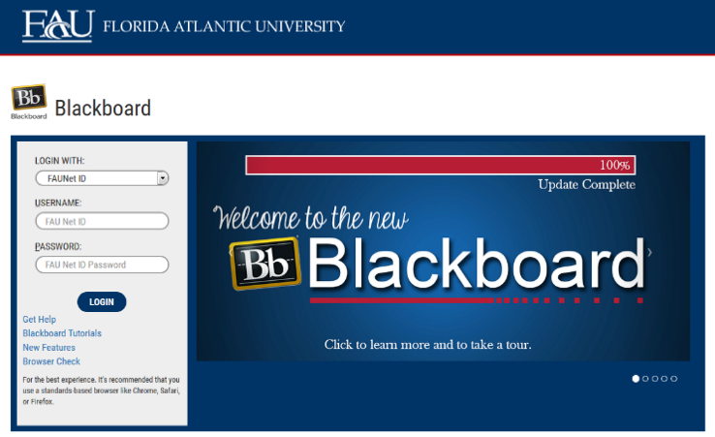
E-mail: Your FAU email address will be used.

Computer: This course will be web assisted through FAU Blackboard site. Some handouts, forms, handbook and resources may be available on the website. Go to the website: http://blackboard.fau.edu (Do not type www).

Vidoes:

Mindfulness:
https://www.youtube.com/watch?v=6p_yaNFSYao

Walking Meditation:
https://www.youtube.com/watch?v=NfPBlRE4RIc

Yoga (Sun Salutation)
https://www.youtube.com/watch?v=uMV4Nq6jpu0

TaiChi (Beginner’s Routine)
https://www.youtube.com/watch?v=vHBR5MZmEsY

De-stress through Breathing
https://www.youtube.com/watch?v=Fpiw2hH-dlc

COURSE OBJECTIVES:

Upon completion of this course, the successful student will demonstrate:

- The understanding of the importance of a positive attitude
- The ability to make big decisions through various techniques
- The ability to manage stress through multiple strategies
- Knowledge of the mind-body connection

Content Outline:

COURSE REQUIREMENTS:

- In-class and Homework Assignments
Students are expected to attend and fully participate in class. Each class session will have either an in-class or homework assignment that will allow students to practice the skills presented in class. Students are responsible for completing the assignments within the given time frame stated by the instructor.
- If I were a Super Hero…
Students will create a description of themselves as a Super Hero. Creation of an image or picture is encouraged. Questions to be answered:
- What is your super power?
- How can you use your super power to make good decisions?
- How does your super power help you or others?
- How does this help you maintain a positive attitude?
Students will either submit a typed paper to the professor or will schedule time during office hours to verbally present to the professor.
- Super Hero Presentation
Students will receive feedback from the professor on their Super Hero description and use that feedback to create a presentation to share with the class.
- Decision-Making Group Presentation
Students will be divded into groups. Each group will be assigned a scenario that they may encounter in their life. The group will have to make some decisions based on the scenario. They will present their scenario and their decisions to the class. Students will individually complete a reflection paper about the experience. Time will be provided in class to work on the assignment.

ASSESSMENT PROCEDURES:

Assignment | Points I Earned | Points Possible
In-class and Homework Assignments |  | 30
If I were a Super Hero…Essay |  | 20
Super Hero Presentation |  | 30
Decision-Making Group Presentation |  | 20
TOTAL |  | 100

GRADING (FAU GRADING SCALE):
Activity scores are cumulative and the grade scale represents percentage of total points earned.
A = 93-100 A- = 90-92 B+= 87-89 B = 83-86
B- = 80-82 C+= 77-79 C = 73-76 C-= 70-72
D+= 67-69 D = 63-66 D-= 60-62 F = Below 60

POLICIES AND PROCEDURES:

ATTENDANCE:
According to University policy, “Students are expected to attend all of their scheduled University Classes and to satisfy all academic objectives as outlined by the instructor.” Attendance includes meaningful, active involvement in all class sessions, class discussions, and class activities as well as professional, ethical, conduct in class. Reasonable accommodations are made for religious observances.

STUDENTS WITH DISABILITIES:
In compliance with the Americans with Disabilities Act (ADA) and FAU policy, students with disabilities who require special accommodations to properly execute course work must register with FAU Student Accessibility Services (SAS) and provide the instructor of this course with a letter from SAS indicates the reasonable accommodations that would be appropriate for this course. SAS offices are located on Boca, Davie and Jupiter campuses. Information regarding SAS services and locations can be found at: http://www.fau.edu/sas/

CODE OF INTEGRITY:
Students at Florida Atlantic University are expected to maintain the highest ethical standards. Academic dishonesty, including cheating and plagiarism, is considered a serious breach of these ethical standards, because it interferes with the University mission to provide a high quality education in which no student enjoys an unfair advantage over any other. Academic dishonesty is also destructive of the University community, which is grounded in a system of mutual trust and places high value on personal integrity and individual responsibility. Harsh penalties are associated with academic dishonesty. For more information, see https://www.fau.edu/ctl/4.001_Code_of_Academic_Integrity.pdf

BIBLIOGRAPHY

Muesse, M. W. (2011). Practicing mindfuless: An introduction to meditation. Chantilly, VA: The Teaching Company.

Schmidt, B. (2015). The practice workbook: A 10-week focus course. Deerfield Beach, FL: HCI.

Hawn Foundation( 2011).The Mind Up curriculum: Brain-Focused Strategies for Learning and Living. (2011). New York, NY: Scholastic Inc.

COURSE SCHEDULE FOR SEMESTER

WEEK | DATE | TOPICS | ASSIGNMENTS
1 |  | What does it mean to choose happiness?  Positive Attitudes | Choosing Happiness
2 |  | -Positive Attitudes  continued | Perspective taking
3 |  | How do I find the SuperHero in me? | Focused attention
4 |  | -My Super Hero  continued | Focused Awareness  HW: Super Hero Paper
5 |  | How can I get focused on my life goals? | The Big Picture
6 |  | What is the connection between my mind and my body?  https://www.youtube.com/watch?v=6p_yaNFSYao | Mindful Awareness
7 |  | -Mind Body connection  Continued  https://www.youtube.com/watch?v=NfPBlRE4RIc | Walking meditation
8 |  | - Mind Body connection  Continued  https://www.youtube.com/watch?v=uMV4Nq6jpu0 | Yoga
9 |  | -Mind Body connection  Continued  https://www.youtube.com/watch?v=vHBR5MZmEsY | Tai-Chi
10 |  | Super Hero Presentations | PRESENTATIONS
11 |  | How can good nutrition & exercise reduce stress? | HW: Food journal
12 |  | -Exercise and Leisure  continued | Happy experiences  HW: What do you enjoy?
13 |  | How do I de-stress?  https://www.youtube.com/watch?v=Fpiw2hH-dlc | Letting go
14 |  | Decision-Making group presentation | PRESENTATIONS
15 |  | What does the big picture of midnfulnes look like? | Acts of Kindness
16 |  | How do I stay in control? | Mindful Action

SLS 2601
SCORING RUBRIC FOR
If I were a Super Hero…

Name: Date: Instructor:

Overall Rating/Points Earned: ____________/20

Project Component | Exceeds Expectation  5 points | Meets Expectations  3-4 points | Does Not Meet Expectations  1-2 points
What is your super power?  _____/5 | Fully answers the question. | Answers part of the question. | Does not answer the question.
How can you use your super power to make good decisions?  _____/5 | Fully answers the question. | Answers part of the question. | Does not answer the question.
How does your super power help you or others?  _____/5 | Fully answers the question. | Answers part of the question. | Does not answer the question.
How does this help you maintain a positive attitude?  _____/5 | Fully answers the question. | Answers part of the question. | Does not answer the question.
SLS 2601
SCORING RUBRIC FOR
Super Hero Presentation

Name: Date: Instructor:

Overall Rating/Points Earned: ____________/30

Project Component | Exceeds Expectation  5 points | Meets Expectations  3-4 points | Does Not Meet Expectations  1-2 points
What is your super power?  _____/5 | Fully answers the question. | Answers part of the question. | Does not answer the question.
How can you use your super power to make good decisions?  _____/5 | Fully answers the question. | Answers part of the question. | Does not answer the question.
How does your super power help you or others?  _____/5 | Fully answers the question. | Answers part of the question. | Does not answer the question.
How does this help you maintain a positive attitude?  _____/5 | Fully answers the question. | Answers part of the question. | Does not answer the question.
Displays interest and enthusiasm  _____/5 | Is enthusiastic and interested. | Is enthusiastic and interested at times. | Is not interested or enthusitastic.
Visual Presentation  _____/5 | Is appealing to look at AND appropriate to the topic. | Is appealing to look at OR appropriate to the topic. | Is not appealing to look at and it not appropriate to the topic.
SLS 2601
SCORING RUBRIC FOR
Decision-Making Group Project

Name: Date: Instructor:

Overall Rating/Points Earned: ____________/20

Project Component | Exceeds Expectation  5 points | Meets Expectations  3-4 points | Does Not Meet Expectations  1-2 points
Group discussions  _____/5 | Fully participated in group discussions. | Participated at times in group discussions. | Did not participate at all.
Group presentation  _____/5 | Fully participated in group presentation. | Participate at times in group presentation. | Did not participate at all.
Individual reflection  _____/5 | Completely answers questions in reflection. | Answers part of the questions in the reflection. | Did not answer questions at all.
Overall group presentation  _____/5 | Overall score for presentation as a group. | Overall score for presentation as a group. | Overall score for presentation as a group.

