Department of Exceptional Student Education
College of Education
Florida Atlantic University

Instructor: Office:
Phone: E-mail:
Office Hours: Class Day/Time:

Course Number: Sls1620

Course Title: Getting Around in the Community

2 Credits

Catalog Description: This course serves as a guide for students to be able to independently access the community through forms of public transportation as well as review pedestrian and bike safety skills.

INSTRUCTOR INTRODUCTION TO THE COURSE: This course is designed for the Florida Atlantic University Academy for Community Inclusion. In this course, students will learn how to utilize public transportation. This includes the ability to obtain transportation information, identify bus schedules and maps, and understanding transportation safety. This course is intended for the student to gain access to the community independently, such as successfully getting to their employment site and campus.

PREREQUISITE or COREQUISITE:
SLS1354 or permission of instructor.
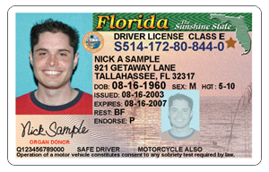
REQUIRED TEXTS or MATERIALS:

Cell Phone
ID card (not OWL card)
Tablet
Additional Materials: All materials will be provided by instructor in class or on Blackboard. Materials will be provided in multiple formats as appropriate.

TECHNOLOGY:

E-mail: Your FAU email will be used for this class

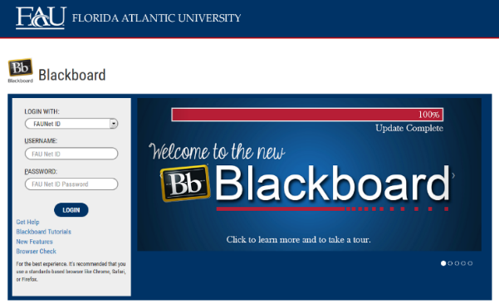
Computer: This course will be web assisted through FAU Blackboard site. Some handouts, forms, handbook and resources may be available on the website. Go to the website: http://blackboard.fau.edu (Do not type www).

COURSE OBJECTIVES:
Upon completion of this course, the successful student will be able to demonstrate the following:

- Students will identify the Americans with Disabilities Act and understand what it means for people with disabilities and their public transportation options.
- Students will identify directions (north, south, east, west, etc.).
- Students will identify the rules of pedestrian safety skills.
- Students will learn how to find information about places they wish to go by public transportation.
- Students will learn how to use a bus/train schedule and map to plan a trip.
- Students will learn how to plan a trip.
- Students will learn what environment factors they must consider while using a form of public transportation.
- Students will effectively demonstrate pedestrian and bicycle safety.
- Students will learn the importance of carrying an ID card and cell phone while using public transportation.
- Students will demonstrate transportation safety rules.

Content Outline:

COURSE REQUIREMENTS: (See Appendix for assignment rubrics)

- Pedestrian Safety (25 points)
Students will have a class mate, a roommate or a job coach video record themselves using their tablet as they show how to successfully cross the street. The student may also decide to record themselves riding their bike and crossing the street if they plan to use their bicycle to get around the community. Students must demonstrate the following skills: stopping at the curb or corner, looking for traffic in all directions, pressing the walk button for the correct direction of crossing, obeying the walk/don’t walk signs, quickly crosses the crosswalk without running and walking a safe distance from the street while on the sidewalk. The video should be no longer than 5 minutes. Students will email their video to the instructor for submission on:

- My Bus Route (40 points)
In this assignment, students will research the bus route they take from their home to get to FAU Jupiter campus, the grocery store, the mall, the bank, and their favorite restaurant. There will be a total of five bus routes that the student will have to find information for. The student will format this information in the following ways, in a PowerPoint, in a video, or with a map. Each destination needs the route number, the time pick-up or drop-off occurs, the beginning and end destination, and any other further transportation (walking, biking, etc.) required to get to the destination. For one destination (student’s choice), the student will convey how to get back home as well. Students will submit this assignment via email to the instructor on:

- Taking My Trip (30 points)-
In this assignment students will use a video diary to document their public transportation trip from home to a destination of their choice. In the video diary students will share the bus route they used, the time they got on and off the bus, their thoughts and feelings during the trip, and some of the places they saw as they were going along on their trip. Students will end their video at the final destination. The students will share their trip in class on:

4) In Class Assignments and Homework- (20 points) Students are expected to attend and fully participate in class. Each class session will have either an in- class or homework assignment that will allow students to practice the skills presented in class. Students are responsible for completing the assignments within the given time frame stated by the instructor.

ASSESSMENT PROCEDURES:

Assignment | Points Earned | Possible
1: Pedestrian Safety |  | 25
2: My Bus Route |  | 40
3: Taking My Trip |  | 30
4: In Class Assignments and Homework |  | 20
TOTAL |  | 100

GRADING (FAU GRADING SCALE):
Activity scores are cumulative and the grade scale represents percentage of total points earned.
A = 93-100 A- = 90-92 B+= 87-89 B = 83-86
B- = 80-82 C+= 77-79 C = 73-76 C-= 70-72
D+= 67-69 D = 63-66 D-= 60-62 F = Below 60

POLICIES AND PROCEDURES:

ATTENDANCE:
According to University policy, “Students are expected to attend all of their scheduled University Classes and to satisfy all academic objectives as outlined by the instructor.” Attendance includes meaningful, active involvement in all class sessions, class discussions, and class activities as well as professional, ethical, conduct in class. Reasonable accommodations are made for religious observances.

STUDENTS WITH DISABILITIES:
In compliance with the Americans with Disabilities Act (ADA) and FAU policy, students with disabilities who require special accommodations to properly execute course work must register with FAU Student Accessibility Services (SAS) and provide the instructor of this course with a letter from SAS indicates the reasonable accommodations that would be appropriate for this course. SAS offices are located on Boca, Davie and Jupiter campuses. Information regarding SAS services and locations can be found at: http://www.fau.edu/sas/

CODE OF INTEGRITY:
Students at Florida Atlantic University are expected to maintain the highest ethical standards. Academic dishonesty, including cheating and plagiarism, is considered a serious breach of these ethical standards, because it interferes with the University mission to provide a high quality education in which no student enjoys an unfair advantage over any other. Academic dishonesty is also destructive of the University community, which is grounded in a system of mutual trust and places high value on personal integrity and individual responsibility. Harsh penalties are associated with academic dishonesty. For more information, see https://www.fau.edu/ctl/4.001_Code_of_Academic_Integrity.pdf

BIBLIOGRAPHY

Becoming a comprehensive transition program. (n.d.). Retrieved October 12, 2015, from http://www.thinkcollege.net/topics/becoming-a-comprehensive-transition-program

Buses & trains for everyone: Curriculum. (n.d.). Retrieved October 20, 2015, from http://www.projectaction.org

Grigal, M., & Hart, D. (2010). Think college: Postsecondary education options for students with intellectual disabilities. Baltimore, MD: Paul H. Brookes Publishing Co.
Palm Tran public transportation: Going places. (n.d.). Retrieved October 20, 2015, from http://www.palmtran.org/igo

COURSE SCHEDULE FOR SEMESTER

Week | DATE | TOPICS | ASSIGNMENTS
1 |  | Overview of Syllabus  Introduction to Course | Hmwk: collect required materials for class
2 |  | What are my options to get around the community? | Hmwk: complete Transportation Use survey
3 |  | How can I be a safe pedestrian? | Hmwk: Brainstorm important rules to remember while being a pedestrian
4 |  | How do I safely cross the street by walking or on a bike? | Cross Walk Demo In Class-Hmwk: Practice the safety procedures when crossing the street
5 |  | Why do we use safety signs? | Hmwk: Complete Safety Signs identification worksheet
6 |  | How can I prepare for my first trip on the bus? | Pedestrian Safety Due
7 |  | Why are directions important? | Hmwk: Read Transportation “People on the Move” pg. 18
8 |  | How do I read a map? | Hmwk: Look up and print out a map of Palm Beach County to bring to class
9 |  | How do I following a bus route? | Hmwk: Complete Transportation “People on the Move” pg. 11 with map
10 |  | How can I stay safe while using transportation? | My Bus Route Due
11 |  | Why should I carry my ID and cell phone? | Hmwk: Bring your ID card and Cell Phone to class
12 |  | What are my personal responsibilities when planning a trip? | Hmwk: Complete “Things to Consider for When Traveling”
13 |  | How do I plan a trip? | Hmwk: Complete “Things to Plan for When Traveling”
14 |  | Take the Trip | Bus Demo Activity In Class- Bring all necessary items for taking a trip
15 |  | Take the Trip | Taking My Trip Due

Appendix A- Assignment Rubrics

Pedestrian Safety | Exceeds Expectations | Meets Expectations | Does Not Meet Expectations
Video

_____/5

Content Requirements

_____/10

Appropriate Safety Rules

____/10

My Bus Route | Exceeds Expectations | Meets Expectations | Does Not Meet Expectations
Correct Bus Routes

_____/15

Completed Destinations

_____/10

Presentation/Map

_____ /15

Taking My Trip | Exceeds Expectations | Meets Expectations | Does Not Meet Expectations
Beginning Location

_____/5

Bus Route

_____/5

Destination

____/5

Trip Experience/Video Diary

_____/15

