Department of Exceptional Student Education
College of Education
Florida Atlantic University

Instructor: Office:
Phone: E-mail:
Office Hours: Class Day/Time:

Insert Instructor Picture Here

Course Number: Sls1331

2 Credits

Course Title: Business Technology for Community Living

Catalog Description: Introduces students to the technology utilized in the business world including resume writing and editing, info-searching through the internet, Microsoft office skills, and clerical skills.

INSTRUCTOR INTRODUCTION TO THE COURSE: This course is designed for the Florida Atlantic University Academy for Community Inclusion. In this course, students will learn how to utilize Microsoft office and technology in a business setting or for the purpose of business related tasks. Students will learn how to edit their resume, utilize excel, word, and PowerPoint for business related entities, as well as using the internet for online resources, and learning the technology related tasks of an office assistant/clerk.

PREREQUISITE or COREQUISITE:
none

REQUIRED TEXTS or MATERIALS:
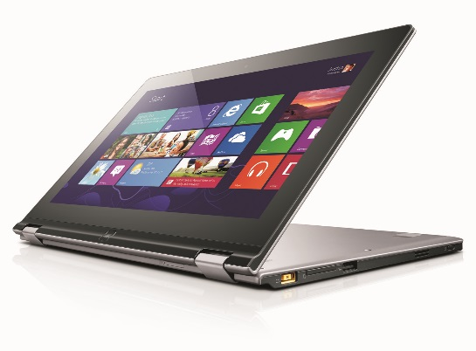
All materials will be provided by instructor in class or on Blackboard. Materials will be provided in multiple formats as appropriate.
Tablet/ laptop

TECHNOLOGY:

E-mail: Your FAU email will be used for this class

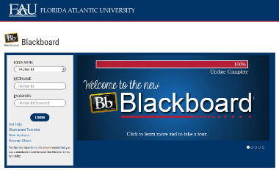
Computer: This course will be web assisted through FAU Blackboard site. Some handouts, forms, handbook and resources may be available on the website. Go to the website: http://blackboard.fau.edu (Do not type www).
Videos:
- Copiers-
https://www.youtube.com/watch?v=6OxlIHe_1r8

- Business Professional-
https://www.youtube.com/watch?v=0o3INMBL58w

COURSE OBJECTIVES:
Upon completion of this course, the successful student will be able to demonstrate the following:

- Students will construct and edit their resume using Microsoft Word.
- Students will create a sum sheet and a graph in excel.
- Students will make a PowerPoint that presents an office or a business related issue.
- Students will research jobs and community resources using a search engine.
- Students will learn how to make copies and print documents/PowerPoints in multiple formats.
- Students will learn how to scan documents and fax documents.
- Students will answer the phone in a professional manner and take messages for other staff.
- Students will write emails to other businesses and staff with professionalism.

Content Outline:

COURSE REQUIREMENTS: (See Appendix for assignment rubrics)

1) Technology Interview (20 points)- Students will interview an office assistant or business professional on campus and ask them questions about the different types of technology they use on a daily basis. The template for the interview can be found posted on Blackboard. Students will need to set up an appointment and reach out to this person prior to meeting with them. Students will submit their typed in Word interview via Blackboard as well. Due date:

2) Email Log (20 points)- In this assignment students will select 10 email correspondences that they have had with other business, professionals, or work related areas. Students will be expected to use professionalism when writing their emails. These emails should not be ones written to friends. Students can use emails that they have had with job coaches, instructors, employers, etc. Students will print their emails, scan them, and submit them via blackboard on:

3) Business PowerPoint (40 points)- Students will work in groups of 2 to construct a PowerPoint on a topic that could be used in a business setting. The topic will be chosen in class from a given list. The PowerPoint will need to contain 1 chart created in word, 1 graph or sum sheet created in excel, and consist of 5-10 Power Point slides. Proper editing and visuals must be utilized when creating the Power Point. The Power Point will require a title page. Students will research and create their own material and present it as if they were asked to give this presentation in their own business setting. Most of the material and items in the PowerPoint will be hypothetical or created by the student. Some material will need to be researched and factual. Students can use hypothetical numbers/data when making graphs, sum sheets, or charts. If a student has a topic that they would like to present that is not listed below, they are welcomed to do so with instructor approval. The last slide of the presentation will include a list of resources that were used in making the presentation. Students will present the PowerPoint in class on:

PowerPoint Business Topics:
- Business etiquette
- Making effective use of email
- Basic methods of research in business
- Use of Audio and Visual in Business
- Company Policies
- Effective Customer Service
- Appropriate Business Communication
- Proper use of Office Technology (Phones, Copiers, Fax, Scan)

4) In Class Assignments and Homework- (20 points) Students are expected to attend and fully participate in class. Each class session will have either an in- class or homework assignment that will allow students to practice the skills presented in class. Students are responsible for completing the assignments within the given time frame stated by the instructor.

ASSESSMENT PROCEDURES:

Assignment | Points Earned | Possible
1: Technology Interview |  | 20
2: Email Log |  | 20
3: Business Power Point |  | 40
4: In Class Assignments and Homework |  | 20
TOTAL |  | 100

GRADING (FAU GRADING SCALE):
Activity scores are cumulative and the grade scale represents percentage of total points earned.
A = 93-100 A- = 90-92 B+= 87-89 B = 83-86
B- = 80-82 C+= 77-79 C = 73-76 C-= 70-72
D+= 67-69 D = 63-66 D-= 60-62 F = Below 60

POLICIES AND PROCEDURES:

ATTENDANCE:
According to University policy, “Students are expected to attend all of their scheduled University Classes and to satisfy all academic objectives as outlined by the instructor.” Attendance includes meaningful, active involvement in all class sessions, class discussions, and class activities as well as professional, ethical, conduct in class. Reasonable accommodations are made for religious observances.

STUDENTS WITH DISABILITIES:
In compliance with the Americans with Disabilities Act (ADA) and FAU policy, students with disabilities who require special accommodations to properly execute course work must register with FAU Student Accessibility Services (SAS) and provide the instructor of this course with a letter from SAS indicates the reasonable accommodations that would be appropriate for this course. SAS offices are located on Boca, Davie and Jupiter campuses. Information regarding SAS services and locations can be found at: http://www.fau.edu/sas/

CODE OF INTEGRITY:
Students at Florida Atlantic University are expected to maintain the highest ethical standards. Academic dishonesty, including cheating and plagiarism, is considered a serious breach of these ethical standards, because it interferes with the University mission to provide a high quality education in which no student enjoys an unfair advantage over any other. Academic dishonesty is also destructive of the University community, which is grounded in a system of mutual trust and places high value on personal integrity and individual responsibility. Harsh penalties are associated with academic dishonesty. For more information, see https://www.fau.edu/ctl/4.001_Code_of_Academic_Integrity.pdf

BIBLIOGRAPHY

Brolin, D.E. (1997). Life centered career education (pp. 99-125). Reston, VA: The Council for Exceptional Children.

Grigal, M., & Hart, D. (2010). Think college: Post-secondary options for students with intellectual disabilities. Baltimore, MD: Paul H. Brookes Publishing Co.

Hanley-Maxwell, C., & Collet-Klingenberg, L. (2012). Preparing students for employment. In P. Wehman & J. Kregel (Eds.), Functional curriculum for elementary and secondary students with special needs (pp. 529-559). Austin, TX: PRO-ED.

McDonnell, J., & Hardman, M.L. (2010). Successful transition programs: Pathways for students with intellectual and developmental disabilities (2nd Ed.). Thousand Oaks, CA: Sage Publications, Inc.

COURSE SCHEDULE FOR SEMESTER

Week | DATE | TOPICS | ASSIGNMENTS
1 |  | Overview of Syllabus  Introduction to Course | Hmwk: collect required materials for class
2 |  | What are the differences in Microsoft Office programs? | Hmwk: Make sure that all programs of Microsoft Office are installed to tablet and working properly
3 |  | When do I use Microsoft Word? | Bring Tablet to Class with Resume  Hmwk: Edit and submit your final resume
4 |  | When do I use Microsoft Excel? | Bring Tablet to Class  Hmwk: Make a bar graph with the data given from class
5 |  | When do I use Microsoft PowerPoint? | Technology Interview Due
6 |  | How do I make copies? | Hmwk: Watch video https://www.youtube.com/watch?v=6OxlIHe_1r8
7 |  | What are the benefits of scanning and faxing? | Hmwk: Print out any document and scan it to your instructor
8 |  | What can I use to research in the business world? | Bring Tablet to Class  Hmwk: Make a list of different resources you could use when working in a business setting. Email this list to your instructor
9 |  | What is professionalism? | Hmwk: Watch video https://www.youtube.com/watch?v=0o3INMBL58w
10 |  | How do I write a professional email? | Hmwk: Practice emailing your instructor, peer mentor, job coach, etc. This will be useful in creating the Email Log!
11 |  | How should I answer the phone in an office? | Hmwk: Talk to a peer mentor or job coach and have them call you. Answer the phone as professionally as possible. We will discuss in class.
12 |  | What do I write or say when taking and leaving messages? | Email Log Due
13 |  | Business PowerPoint Q&A small groups | Bring tablet and materials to class
14 |  | Presentations | Business PowerPoint Due
15 |  | Presentations | Business PowerPoint Due
Appendix A- Assignment Rubrics

Technology Interview | Exceeds Expectations | Meets Expectations | Does Not Meet Expectations
Content

_____/10

Format

_____/10

Email Log | Exceeds Expectations | Meets Expectations | Does Not Meet Expectations
Professionalism

_____/ 10

Quantity

_____/ 5

Printing and Scanning

____/ 5

Business PowerPoint | Exceeds Expectations | Meets Expectations | Does Not Meet Expectations
PowerPoint

_____/10

Oral Presentation

_____/10

Content/Data
-graphs, facts, information, visuals

____/15

Resources

_____ /5

