Department of Exceptional Student Education
College of Education
Florida Atlantic University

Instructor: Office:
Phone: E-mail:
Office Hours: Class Day/Time:

Insert Instructor Photo Here

Course Number: ABX 1001

Course Title: Personal Finance FOR COMMUNITY LIVING

2 Credits

Catalog Description:

This course is designed to teach students the personal finance skills they need to succeed in adult life. Topics include, but are not limited to determining financial goals, budgeting, banking and credit.

INSTRUCTOR INTRODUCTION TO THE COURSE:

In this course, student will have the opportunity to gain valuable personal finance skills. Students will learn how to open and maintain a bank account, pay bills, and create a personal budget. Students will learn about direct deposit of pay checks and what employers are required to withhold from their checks to pay taxes and social security. Students will also learn about putting money aside for retirement and investments.

PREREQUISITE:
No pre- or co-requisites.

Note: This class may be repeated to ensure mastery of the skills presented in the course objectives.

REQUIRED TEXTS or MATERIALS:

All materials will be provided by instructor in class or on Blackboard. Materials will be provided in multiple formats as appropriate.

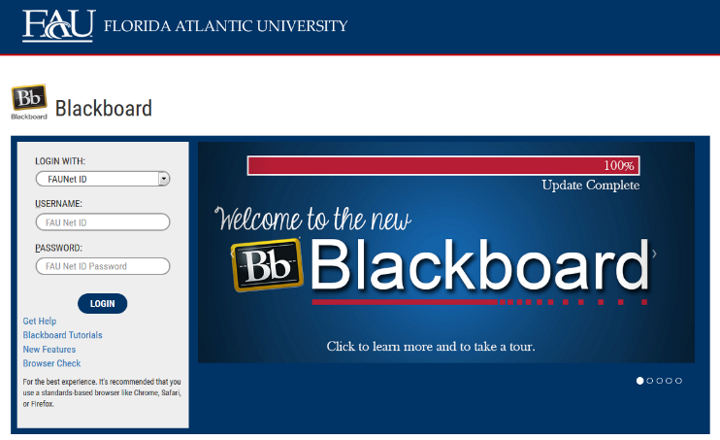
TECHNOLOGY:

E-mail: Your FAU email address will be used.

Computer: This course will be web assisted through FAU Blackboard site. Some handouts, forms, handbook and resources may be available on the website. Go to the website: http://blackboard.fau.edu (Do not type www).

COURSE OBJECTIVES:

Upon completion of this course, the successful student will be able to demonstrate:

- An understanding of financial responsibility
- An understanding of the banking process
- An understanding of budgeting
- An understanding of credit
- An understanding of debt
- An understanding of consumer awareness
- An understanding of identity theft

Content Outline:

COURSE REQUIREMENTS:

- Budget Presentation

Because this is the Mastery Assignment, students must obtain a grade of 85% to move on to the next phase of the Academy programming. See Student handbook for clarification of the Mastery Assignment Rules. A scoring rubric is included in this syllabus to help you understand how your PowerPoint will be graded. This Mastery Assignment earns up to 40 points.

2) In-class and Homework Assignments
Students are expected to attend and fully participate in class. Each class session will have either an in- class or homework assignment that will allow you to practice the skills presented in class. Students are responsible for completing the assignments within the given time frame stated by the faculty instructor.

3) Mid-Term Exam
Students will engage in a comprehensive exam covering all material taught during the first half of the semester. A study guide will be provided a week prior to the exam.

ASSESSMENT PROCEDURES:

Assignment | Possible | Points I earned
Mid-Term Exam | 30
Budget Presentation | 40
In-class and Homework Assignments | 30
Total points | 100

GRADING (FAU GRADING SCALE):
Activity scores are cumulative and the grade scale represents percentage of total points earned.
A = 93-100 A- = 90-92 B+= 87-89 B = 83-86
B- = 80-82 C+= 77-79 C = 73-76 C-= 70-72
D+= 67-69 D = 63-66 D-= 60-62 F = Below 60

POLICIES AND PROCEDURES:

ATTENDANCE:
According to University policy, “Students are expected to attend all of their scheduled University Classes and to satisfy all academic objectives as outlined by the instructor.” Attendance includes meaningful, active involvement in all class sessions, class discussions, and class activities as well as professional, ethical, conduct in class. Reasonable accommodations are made for religious observances.

STUDENTS WITH DISABILITIES:
In compliance with the Americans with Disabilities Act (ADA) and FAU policy, students with disabilities who require special accommodations to properly execute course work must register with FAU Student Accessibility Services (SAS) and provide the instructor of this course with a letter from SAS indicates the reasonable accommodations that would be appropriate for this course. SAS offices are located on Boca, Davie and Jupiter campuses. Information regarding SAS services and locations can be found at: http://www.fau.edu/sas/

CODE OF INTEGRITY:
Students at Florida Atlantic University are expected to maintain the highest ethical standards. Academic dishonesty, including cheating and plagiarism, is considered a serious breach of these ethical standards, because it interferes with the University mission to provide a high quality education in which no student enjoys an unfair advantage over any other. Academic dishonesty is also destructive of the University community, which is grounded in a system of mutual trust and places high value on personal integrity and individual responsibility. Harsh penalties are associated with academic dishonesty. For more information, see https://www.fau.edu/ctl/4.001_Code_of_Academic_Integrity.pdf

BIBLIOGRAPHY

Federal Deposit Insurance Company (n.d.) Money smart: An adult education program. Retrieved October 20, 2015, from http://www.fdic.gov/moneysmart

Grigal, M., & Hart, D. (2010). Think college: Postsecondary education options for students with intellectual disabilities. Baltimore, MD: Paul H. Brookes Publishing.

Visa (2015). Practical money skills for life: Lessons Grades 9-12 Retrieved October 20, 2015, from: https://www.practicalmoneyskills.com/foreducators/lesson_plans/highschool.php

Van Reusen, A.K., Bos, C., Schumaker, J, & Deshler, D. (2007). The self-advocacy strategy for enhancing student motivation and self-determination. Lawrence, KS: Edge Enterprises.

Wehmeyer, M. (2007). Promoting self-determination in students with developmental disabilities. New York, NY: The Guilford Press.

ABX 1001 Sem 20XX
COURSE SCHEDULE

SESSION | Week | TOPICS | ASSIGNMENTS
1 |  | Intro to Personal Finance | Review of Syllabus
2 |  | What difference do your decision make?  -Being Financially Responsible | HW: What Will it Cost You? Activity
3 |  | How do you set money goals? | HW: Personal Finance Goals
4 |  | What does your paycheck mean? | HW: Understanding Paystubs
5 |  | How do you make a budget and stick to it? | HW: Spending Diary
6 |  | What are bank accounts used for? | HW: Reading a Bank Statement
7 |  | Mid-Term Exam | Mid-Term exam
8 |  | How can you be a wise shopper? | HW: Comparison Shopping
9 |  | Why do you need credit? | HW: Shopping for Credit
10 |  | What is the down side of credit? | HW: Scenarios
11 |  | How do you protect your identity? | HW: Protecting Yourself
12 |  | Protecting your money  -continued
13 |  | How can you save and invest? | HW: Saving Your Money
14 |  | Investing  -continued | HW: Locate contact info of a financial professional
15 |  | Presentations | Budget Presentations Due

What Will It Cost YOU?

Where do you want to live next year?

1) Gather some information:

What will be your expected income?

What will be your transportation costs?

What will be your cost of rent?

What will be your school costs?

Will you have any financial aid options?

2) List some alternatives:

How much will these cost?

Could you live at home?

Live at home and pay rent to your parents?

Rent an apartment?

Live alone?

Share an apartment?

Live in the dorm?

Live in a sorority or Fraternity house?

Live in a mobile home park?

3) Consider the consequences of each choice and evaluate the alternatives.

4) Select the best course of action.

5) Evaluate the results.

