LIT 3184: Irish Literature
T 4-6:50 / CU 321
Spring 2019
3 credits
Dr. Ulin
Office: CU 349
Phone: (561) 297-3830
Office Hours: T 2-4
Email: julin@fau.edu

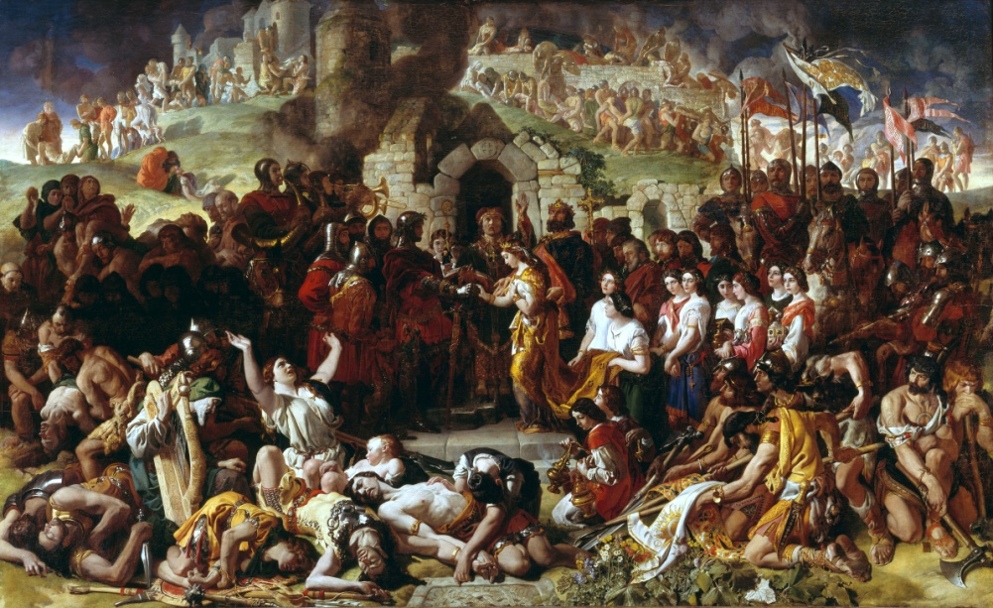
Figure 1 Daniel Maclise, The Marriage of Strongbow and Aoife (c. 1854)

Course Description/Objectives:

“The moment we got rid of [English] tyranny, we rushed to enslave ourselves.”
–George Bernard Shaw (1928)

“This is the final, but bitter triumph of oppression. It teaches the oppressed to oppress themselves more effectively than any external agency could do.”
–Seamus Deane, The Field Day Anthology of Irish Writing (1991)

This course will focus on Irish literature from 1980-2007. The literature of this period opens with “The Troubles,” in which over 3,600 people primarily in Northern Ireland were killed over the course of three decades from 1968-1998. We will then turn to the 1998 Good Friday/Belfast Agreement between Ireland and England, which brought an end to “The Troubles” and brought peace to the region. Our course concludes with Ireland’s move out of the colonial paradigm and its transformation into a European economic power. The Celtic Tiger economic boom (1998-2008) transformed Ireland from an emigrant’s point of departure to a multiracial society and a destination for immigrants, asylum seekers and many of its own returnees. In addition to a primary focus on the relationship among Ireland, England, Europe, and the U.S. as depicted in these texts, the literature will deal with the legacy of partition, depictions of sacrifice and violence, the internal oppression fostered by a narrow nationalism, the figure of the child or adolescent, and challenges to versions of an “authentic” Ireland.

Catalog Description:

Irish Literature (LIT 3184) 3 credits. An exploration of the development of the Irish literary tradition; selections may include Irish language literature in translation, folklore, fiction, poetry, and drama from writers such as Merriman, Swift, Joyce, Yeats, Bowen, Beckett, Heaney, Boland, and Ní Dhomhnaill.
Course texts:

Roddy Doyle, The Commitments (1987)
Patrick McCabe, The Butcher Boy (1992)
Edna O’Brien, Down by the River (1996)
Seamus Deane, Reading in the Dark (1996)
Jamie O’Neill, At Swim Two Boys (2001)

Course Grades:

Attendance* and Participation (incl. in class writing and quizzes): 20% [You will be allowed two absences. Any absences beyond that will affect your grade by a letter grade (for example, dropping from an A to an A-). If an emergency arises, please email me in advance of our class meeting, and we will arrange to meet to cover any material discussed in class. I will do my best to accommodate to absences due to unforeseeable emergencies. After three absences (excused or unexcused), however, I reserve the right to meet with you to discuss the viability of your continued enrollment in the course. Please come and speak with me about your absences before you think they have become an issue.]
Discussion Leadership: 10%
4 Formal Papers: 50% (Due by 11:59 via Canvas on the following days: Feb. 5 (Translations or The Commitments), Feb. 27 (The Butcher Boy or Down by the River), March 15 (Reading in the Dark), April 12 (At Swim, Two Boys))
Final Exam: 20%

*Attendance: Students are expected to attend all of their scheduled University classes and to satisfy all academic objectives as outlined by the instructor. The effect of absences upon grades is determined by the instructor, and the University reserves the right to deal at any time with individual cases of non-attendance. Students are responsible for arranging to make up work missed because of legitimate class absence, such as illness, family emergencies, military obligation, court-imposed legal obligations or participation in University approved activities. Examples of University-approved reasons for absences include participating on an athletic or scholastic team, musical and theatrical performances and debate activities. It is the student’s responsibility to give the instructor notice prior to any anticipated absences and within a reasonable amount of time after an unanticipated absence, ordinarily by the next scheduled class meeting. Instructors must allow each student who is absent for a University-approved reason the opportunity to make up work missed without any reduction in the student’s final course grade as a direct result of such absence.

Grade Scale: Florida Atlantic University follows a plus/minus (+/-) grading system. Numeric values for this course are as follow:

A | A- | B+ | B | B- | C+ | C | C- | D | F
93-100 | 90-92 | 87-89 | 83-86 | 80-82 | 77-79 | 73-76 | 70-72 | 60-69 | 0-59

Disability policy statement In compliance with the Americans with Disabilities Act Amendments Act (ADAAA), students who require reasonable accommodations due to a disability to properly execute coursework must register with Student Accessibility Services (SAS) and follow all SAS procedures. SAS has offices across three of FAU’s campuses – Boca Raton, Davie and Jupiter – however disability services are available for students on all campuses. For more information, please visit the SAS website at www.fau.edu/sas/
Counseling and Psychological Services (CAPS) Center Life as a university student can be challenging physically, mentally and emotionally. Students who find stress negatively affecting their ability to achieve academic or personal goals may wish to consider utilizing FAU’s Counseling and Psychological Services (CAPS) Center. CAPS provides FAU students a range of services – individual counseling, support meetings, and psychiatric services, to name a few – offered to help improve and maintain emotional well-being. For more information, go to http://www.fau,edu/counseling/
Code of Academic Integrity policy statement Students at Florida Atlantic University are expected to maintain the highest ethical standards. Academic dishonesty is considered a serious breach of these ethical standards, because it interferes with the university mission to provide a high quality education in which no student enjoys an unfair advantage over any other. Academic dishonesty is also destructive of the university community, which is grounded in a system of mutual trust and places high value on personal integrity and individual responsibility. Harsh penalties are associated with academic dishonesty. For more information, see University Regulation 4.001. http://www.fau.edu/regulations/chapter4/Reg_4.001_5-26-10_FINAL.pdf
Schedule:

Jan 6 – Introduction, Ireland’s Colonial Origin Story, Easter 1916 Rising and W. B. Yeats’s The Dreaming of the Bones.
Jan 13 –Brian Friel’s Translations (1980)
Jan 20 –The Commitments.
Jan 27 – The Commitments.
Feb 3 – The Butcher Boy.
Feb 10 – The Butcher Boy.
Feb 17 – In class documentary: Sex in a Cold Climate. Down by the River.
Feb 24 – Down by the River. Bring Reading in the Dark to class also.
March 2-8 = Spring Break (No class March 3). Read Reading in the Dark.
March 10 – Reading in the Dark.
March 17 – Happy St. Patrick’s Day! At Swim Two Boys.
March 24 – At Swim Two Boys.
March 31 – At Swim Two Boys.
April 7: Lecture on the “New” Ireland, Doyle’s “The Deportees” and “Guess Who’s Coming for the Dinner” (2007, reserve)
April 14: Last Day of Class.
April 21: Reading Day
April 28: Final Exam

