GUIDELINES FOR DROP METHOD OF ANESTHESIA
Reviewed and Approved by FAU IACUC
Effective Date: January 28, 2022 Last Reviewed/Revised: January 28, 2022

This method of anesthesia is to be used with very short periods where manipulation of the animal is necessary. It is not recommended for short surgeries or perfusions.

- Use proper device (bell jar/desiccator/etc…) that is transparent and allows you to visualize the animal during the anesthesia process. Have gauze ready to soak with isoflurane.
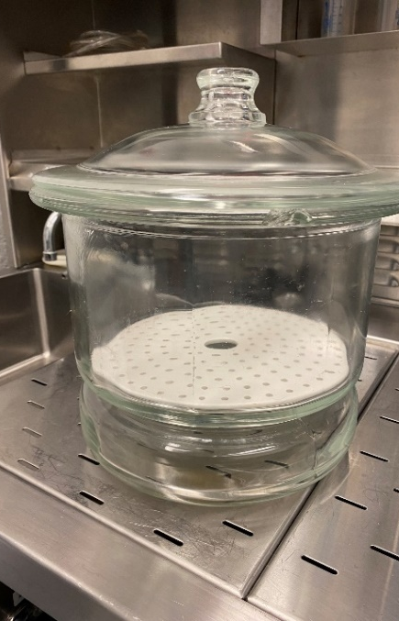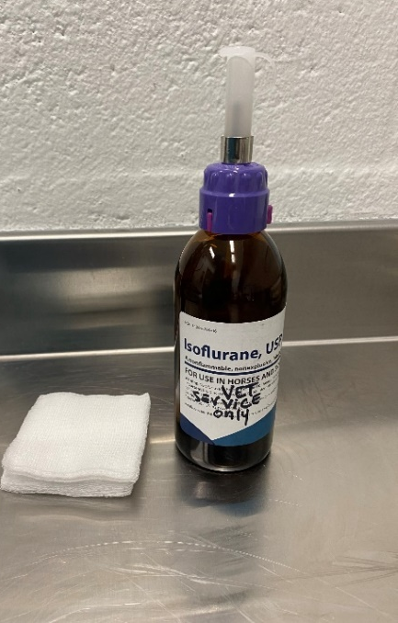
- Ensure that bell jar/desiccator is used under a fume hood to prevent exposure of personnel to waste anesthetic gas. Turn on fume hood.
- Place gauze in the center of the bottom of bell jar/desiccator and replace separator.
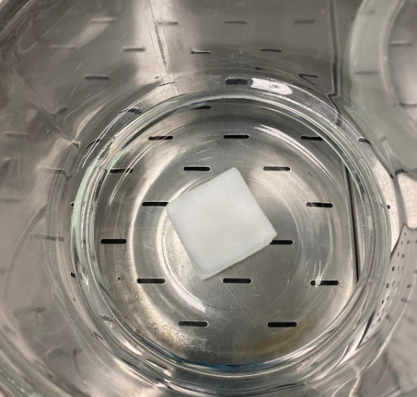

- Using a syringe, aspirate desired amount of isoflurane and place on gauze.
- Place animal in bell jar/desiccator on top of the separator so that the animal cannot come into contact with the soaked gauze.
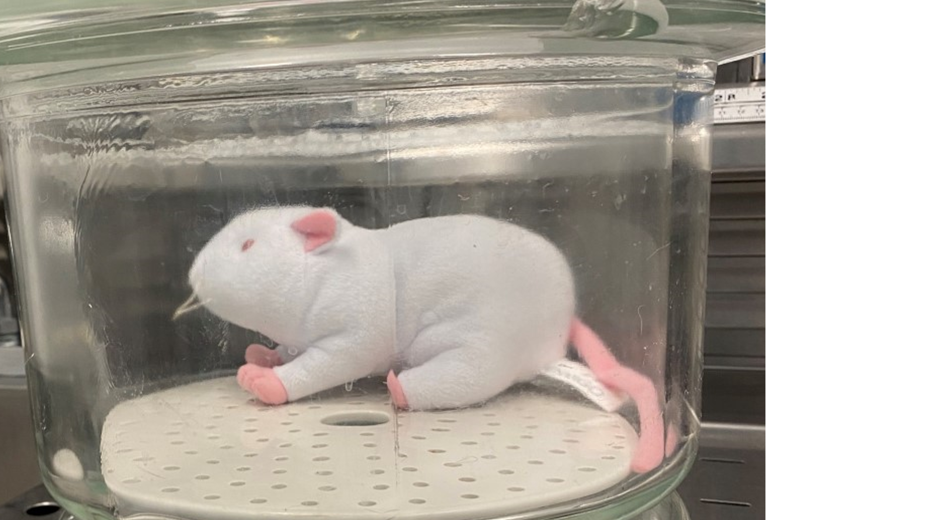
- Place lid on bell jar/desiccator.
- Monitor animal for appropriate depth of anesthesia.
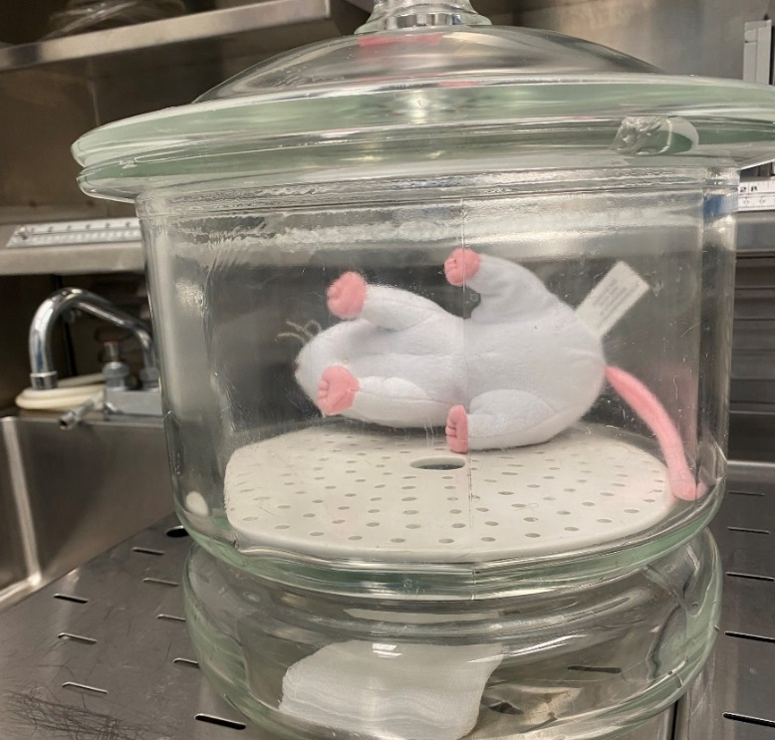
- Slide lid off bell jar/desiccator just enough to remove animal.
- Ensure animal’s depth of anesthesia prior to progressing.
- Once completed, you can slide off the bell jar/desiccator lid and leave in the fume hood. Air dry the used cotton gauze in the hood for 15 minutes, and then discard them by wrapping in a glove/ziplock bag and transferring to a biomedical west disposal bag or bucket.
- Clean and sanitize the bell jar/desiccator.
- Contact a member of the veterinary staff with any questions or to approve your set-up if you do not have a bell jar specifically.
KJS 1/27/2022

