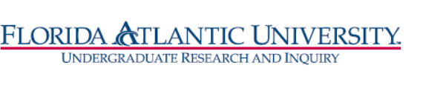
Florida Atlantic University
Undergraduate Research Curriculum Committee
Thursday, April 8, 2021
WebEx meeting from 12:15 to 1:00 pm

- Approve March 11, meeting minutes

- RI Certificate
Members: Dan Meeroff, Nancey France, Tricia Meredith, DCW
Chair: T. Meredith
- Updates
UUPC approved RI Certificate on 3/29/2021

