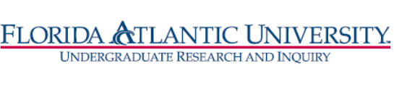
Florida Atlantic University
Undergraduate Research Curriculum Committee
Thursday, March 11, 2021
WebEx meeting from 12:15 to 1:00 pm

- Approve January 14, meeting minutes

- RI Certificate
Members: Dan Meeroff, Nancey France, Tricia Meredith, DCW
Chair: T. Meredith
- Updates
- List of Courses
- Template letter concept for College curriculum Committee

