Aquaculture at the Marine Resources Research Institute-Waddell Mariculture Center, South Carolina, USA

Michael R. Denson*, Aaron Watson, Tanya Darden, Jason Broach, Fabio Casu, Justin Yost and Erin Levesque

Marine Resources Research Institute
217 Fort Johnson road
Charleston, SC 29422-2559
DensonM@dnr.sc.gov

The South Carolina Department of Natural Resources’ Marine Resources Research Institute MRRI) has conducted aquaculture research for almost 50 years. The MRRI is 25,000 sq ft research facility designed to provide essential life history and environmental data for management of the State’s living marine resources. The building is equipped with two wet labs that contain eight individual broodstock maturation systems, algal culture laboratory, three environmental rooms with photothermal control, replicate RAS systems, as well as flow-through extensive tank systems. The MRRI is situated on Charleston Harbor, a high salinity estuary, and the facility is equipped with settled, polished, flow-through seawater and 8 g/L well water.
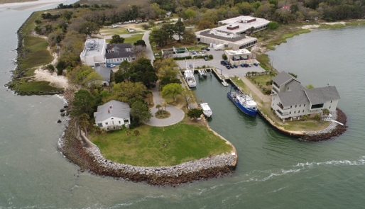

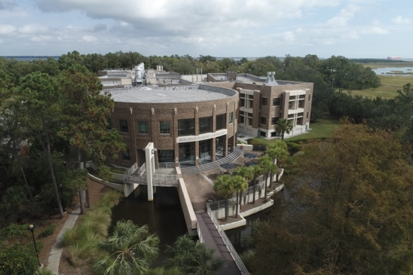
The Waddell Mariculture Center (WMC) is part of the MRRI and is in the Southern part of South Carolina in Bluffton, SC. It is equipped with (12) 0.10 ha, (9) 0.25 ha, and (3) 0.50 ha lined seawater ponds with water control structures. In addition, the Center has a newly renovated laboratory with seven RAS systems for broodstock maturation, larval culture, and juvenile grow-out. WMC is on the Colleton River, another high salinity estuary.

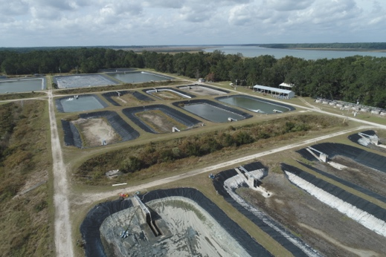
The Hollings Marine Laboratory is a consortium facility shared between SCDNR, NOAA, NIST, College of Charleston and Medical University of South Carolina. The facility contains the MRRI Genetics laboratory, an aquaculture facility with algal room, live feeds production, hatchery, three broodstock maturation rooms, and a RAS system with (24) 6 ft dimeter tanks. Adjacent to the animal production wing is the chemistry wing with two Nuclear Magnetic Spectrometers and numerous Mass Spectrometers.

Scientists from all three facilities and numerous outside partners work cooperatively on questions regarding nutrition, extensive and intensive production, genetic impacts of escapement, and emerging species life history. We are currently working with red drum, seatrout, cobia and tripletail.

