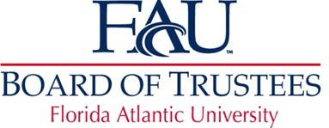

Full Board Meeting
Master Agenda

Friday, December 20, 2019
Conference Call – 10:30 a.m.

Toll Free Number: 1 888 585 9008

The passcode/event number is: 942-002-584

Full Board Meeting
- Roll Call………………………………………………..Trustee Anthony Barbar, Chair
- Public Comments
- New Business
    - Naming Element…………………………….. Brian White, VP, Athletics
- Adjournment

