November 3, 2022

9:30 - 9:45 AM Registration
9:45 -10:00AM Welcome:
Richard Shusterman and Kenneth Holloway, Center for Body, Mind, and Culture, FAU

Session I: Pain and Discomfort Chair: TBD

10:00- 10:45 AM
Crispin Sartwell, Dickinson College
The Self In and As Pain

10:45-11:00AM Break

11:00-11:45 AM
Mark D. Tschaepe, Prairie View A&M University
Interrogating Pain: Somaesthetics of Discomfort as a Strategic Set of Practices

11:45-1:15 PM Lunch

Session II Somaesthetics and the Poetics of Pain Chair: TBD

1:15-2:00 PM
Aleksandra Hernandez, University of Miami
Somaesthetics, Pain, and Emotional Resolution

2:00-2:15 PM Break

2:15-3:00 PM
Diana Allerdyce, Union Institute and University
The Poetics of Pain

3:00-3:15 PM Break

Session III Anthropologies of Pain
Chair: Adriana Garriga-Lopez ?

3:15-4:00 PM
Myron M. Jackson, Western Carolina University
Rule Making or Rule Breaking? Somaesthetics Meets Anthropotechnics

4:00-4:15 PM Break

4:15-5 PM
Mark K. Watson, Concordia University
Feeling Pain in the Body of Another: Languages of Suffering and the Economics of Masochistic Desire in Contemporary Anthropological Inquiry

5PM Reception:

November 4, 2022

Session IV Aesthetics of Pain
Chair: Brian McConnell

9:30-10:15 AM
Bartlomiej Struzik, Academy of Fine Arts in Krakow
Monuments of Pain

10:15-11:00 AM
Yanping Gao, FAU
The Laocoon and its Reconstructions of Gesture and Pain

11:00-11:15 AM Break

Session V Catharsis and Conclusions
Chair: TBD
11:15 AM- Noon
Marta Vaamonde, Universidad Nacional de Educación a Distancia (Spain)
Somatic catharsis: the role of pain in the reconstruction of aesthetic experience and the art of living

12:00 PM-12:30 Concluding Discussions

12:30 Lunch

Conference will be held at:
Culture and Society Building (CU), 3rd Floor Seminar Room

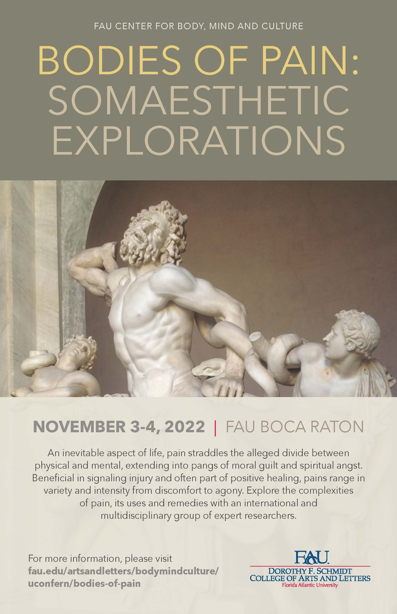
The Center for Body, Mind, and Culture is an interdisciplinary initiative dedicated to promoting research, programming, and teaching of topics concerning the body-mind-culture nexus. The Center’s motivating logic affirms that the three terms constituting its name are essentially interdependent rather than separate entities and that they therefore need to be studied in terms of their interrelations and through interdisciplinary research.
Contact Us
Email: bodymindculture@gmail.com
Web: www.fau.edu/bodymindculture

